IDITAROD TRAIL SLED DOG RACE
STORY IDEAS

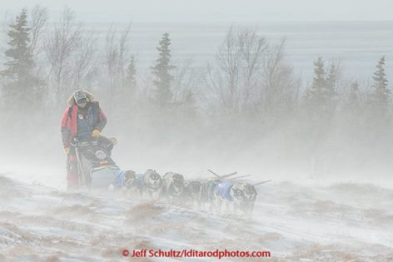
Iditarod Sled Dog Race
You can’t compare it to any other competitive event in the world. A Race of approximately 1,000 miles of the roughest, most beautiful terrain Mother Nature has to offer. She throws jagged mountain ranges, frozen rivers, dense forests, desolate tundra and miles of windswept coast at the mushers and their dog teams. Add to that the temperatures far below zero, winds that can cause a complete loss of visibility, the hazards of overflow, long hours of darkness and treacherous climbs and side hills, and you have the Iditarod. For additional information click here: Iditarod

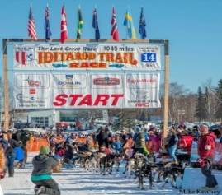
Re-Start in Willow
Begins on the Sunday following the start in Anchorage. The Re-Start is staged on Willow Lake located behind the Willow Community Center. From Willow Lake the mushers will cross Long Lake, Crystal Lake, and Vera Lake. Once they leave Vera Lake they will travel to the Susitna River and on to the Yentna River. For additional information click here: Media Guide

Canine Athletes
The Iditarod Trail Sled Dog Race outlines the responsibility that mushers must follow in the care of their dogs. These athletes are checked by a team of Veterinarians before, during and after the race. Mushers have specialized training and breeding programs. Sled Dogs love to run! For more information click here: Media Guide

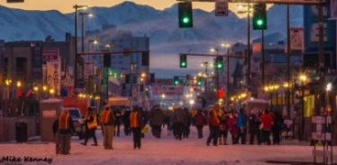
Iditarod Volunteers
It takes approximately 1,500 to 1,800 volunteers to help stage the Last Great Race on Earth. These volunteers come from all over the world to help. They return year after year and give up valuable vacation time to help the race. Be sure and ask a volunteer how long they have helped the race. They will proudly tell you and share their experiences. For more information about volunteers click here: Volunteers

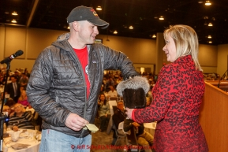
Musher Banquet
The banquet is held the Thursday night before the race start. Mushers pull from a mukluk their starting race order and visit with fans and sponsors from around the world. Store

Largest Payout than any other Sled Dog Race
The Iditarod traditionally pays the highest purse in sled dog history. For more information see Media Guide

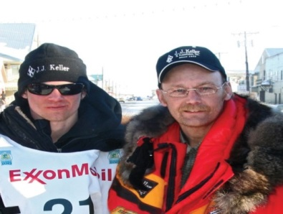
Family Tradition
Mushing is a family affair for several Iditarod mushing families. For instance last year’s champion Dallas Seavey is a third generation musher. His father Mitch is also a champion and his Grandfather Dan ran the first Iditarod. For more information on other Iditarod mushers look here: Mushers

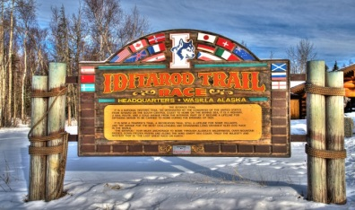
Iditarod Headquarters & Museum
Open year round with free admission. This is a must see part of Alaska history. Trophies, Displays, Photos, with a Video room, Gift Shop filled with souvenirs and memorabilia. They even offer Cart rides in the summer by the son of the “Father of the Iditarod”, Joe Redington Sr. For more information click here: Headquarters & Museum

Iditarod Insider
This program allows fans from around the world to watch the race as it is occurring. There are videos from the trail with reporting from race analysts. The GPS tracker program has fans glued to their computer screens hitting refresh every couple of minutes. Learn more about this here: Insider

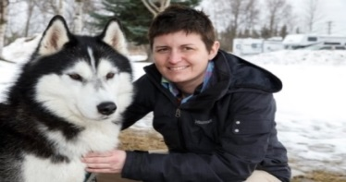
Teacher on the Trail ™
This program began in 1999, when the program’s creator, Andrea “Finney” Aufder Heyde, journeyed along the Iditarod Trail as the First Iditarod Teacher on the Trail™. This nationally acclaimed teaching adventure provides content curriculum and educational stories to schools around the globe. Learn more about the Teacher on the Trail™ program at this link: Teacher on the Trail™

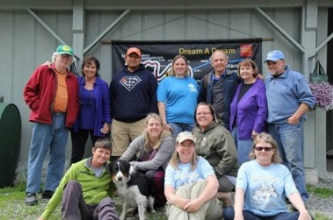
Educational Camps
The education program offers educators a Summer and Winter camp experience. Educators learn how to use Iditarod as a theme in their classrooms. Educators meet in Alaska and are immediately immersed in life at Dream a Dream dog kennel. They meet mushers who share their experiences on the trail and exposed to how to incorporate Math and Science in the Classroom using the Iditarod Sled Dog Race as a tool. For more information see: Education

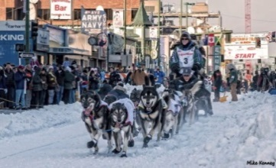
Iditarider Program
Offering the opportunity for fans to bid to ride in a sled as it leaves the Start Line in downtown Anchorage on Saturday. Riders from all over the world have been in sleds. The ride goes 11 miles along some of Anchorage's beautiful trails through parks and snow covered woods. For more information click here: Iditarider

FOR MORE INFORMATION ABOUT IDITAROD SEE:  Iditarod | PLEASE CHECK OUT THE MEDIA GUIDE  Media Guide

